Date:-29.05.2020

IAAS:- infrastructure as a service

Tenant:- user

Multi-tenancy:- multiple user(isolated space for multiple user)it will be a virtual setup

Name_space:- achieve with multi-tenancy(space for evry1)

program:-store,save(hardisk)[blocked storage]; or run(ram,cpu)

Permanent storage:persistent

Temporary storage:emprerhal

To run the data we need CU (ram and cpu__)

CAAS: computer as a service

EC2(elastic compute cloud):- product/service of aws which provide ram and cpu…

NOVA:- service in openstack which provide ram and cpu

STAAS:- storage as a service

Storage:-block,file,object

EBS:elastic block storage in aws( provides service in aws as blocked storage)

Cinder:- provides service in openstack as blocked storage

NAAS->network as a service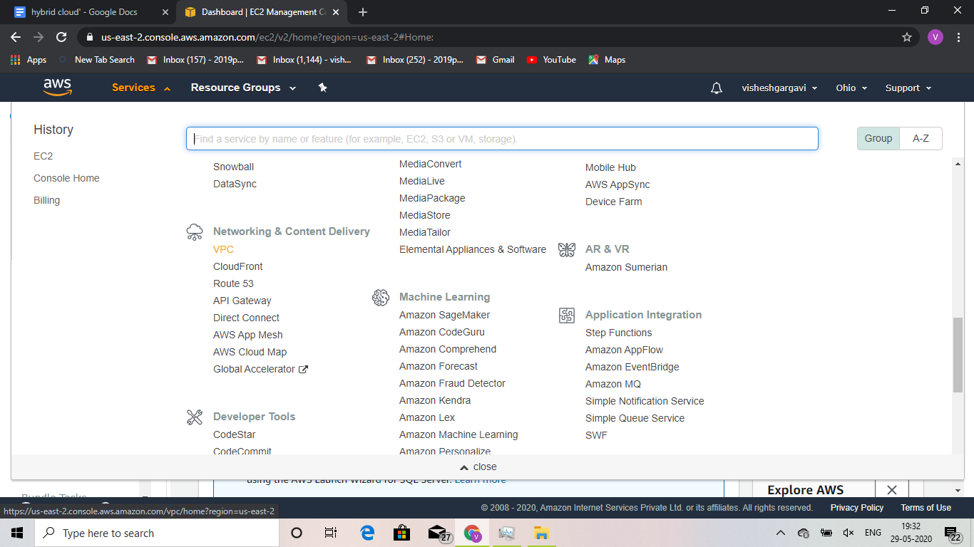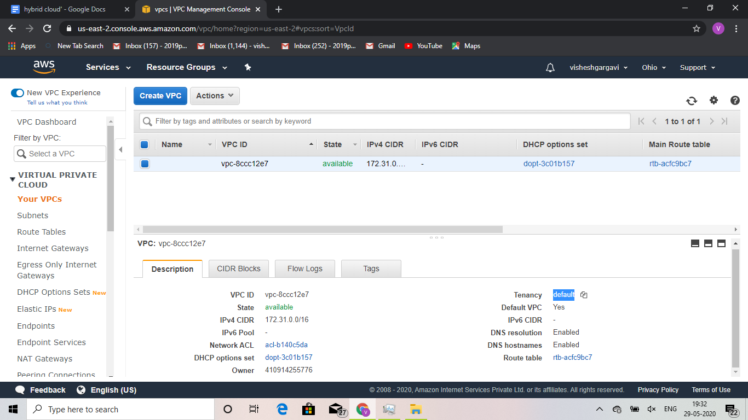VPC:virtual private cloud(NAAS in aws)[in openstack it is neutron]

Lab is knows as subnet

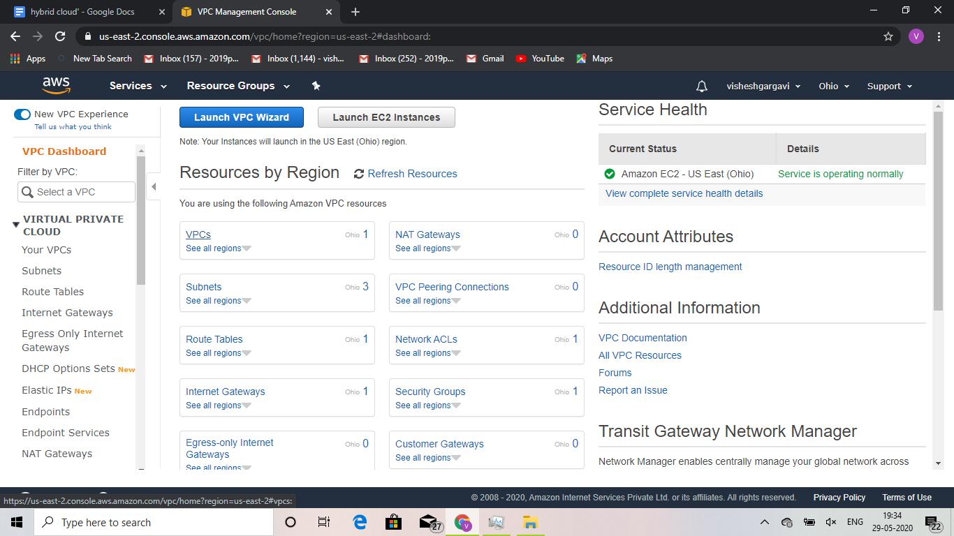

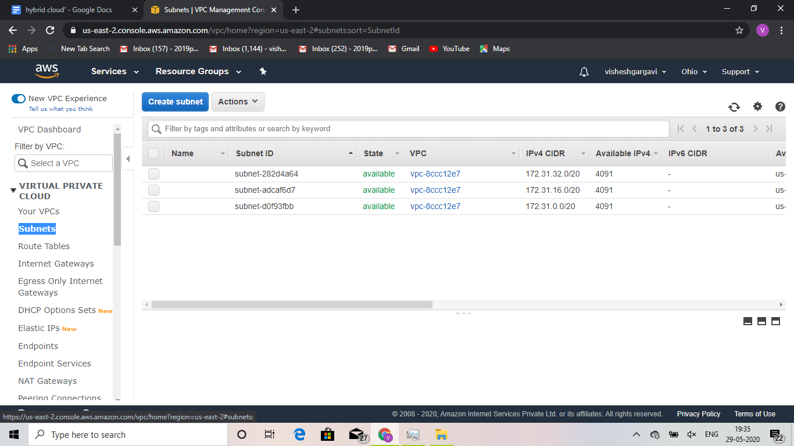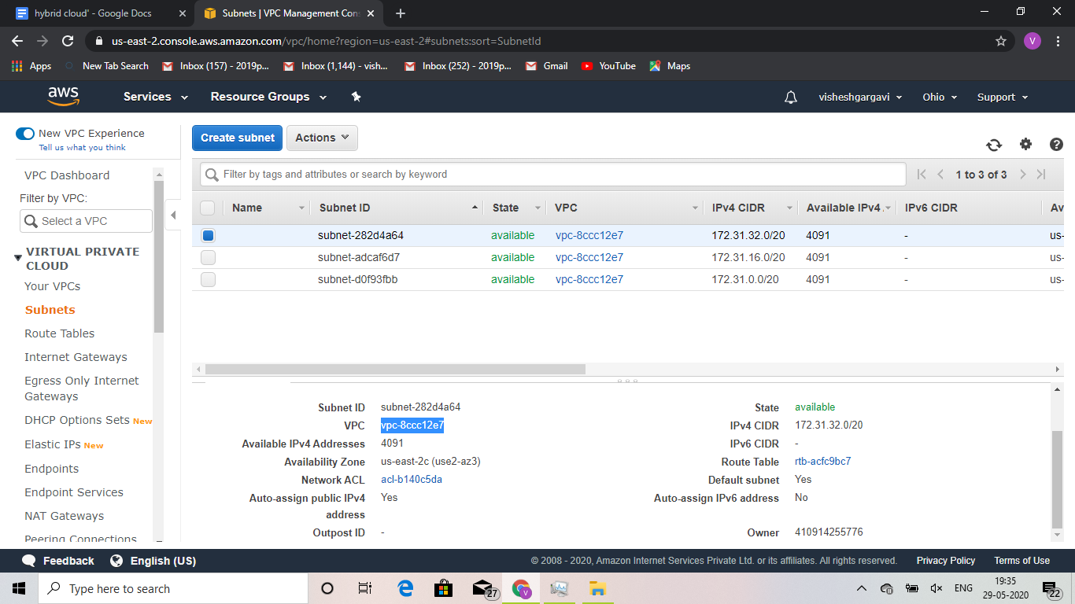

<https://aws.amazon.com/about-aws/global-infrastructure/>

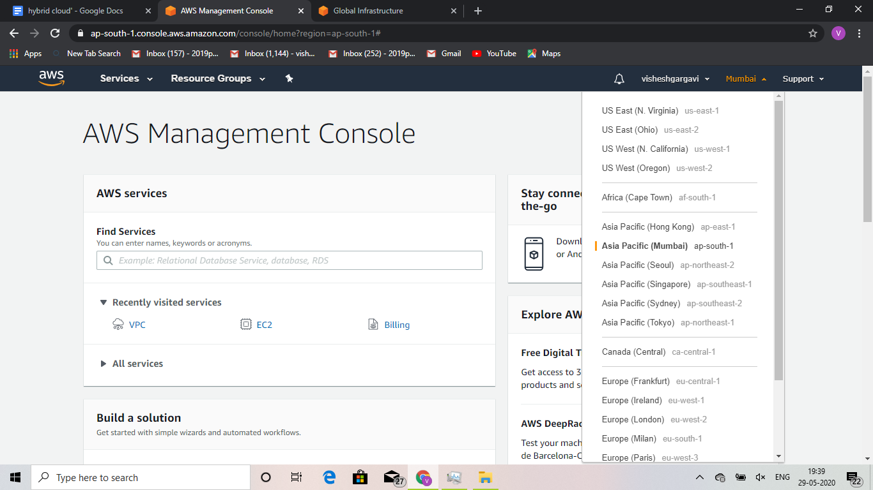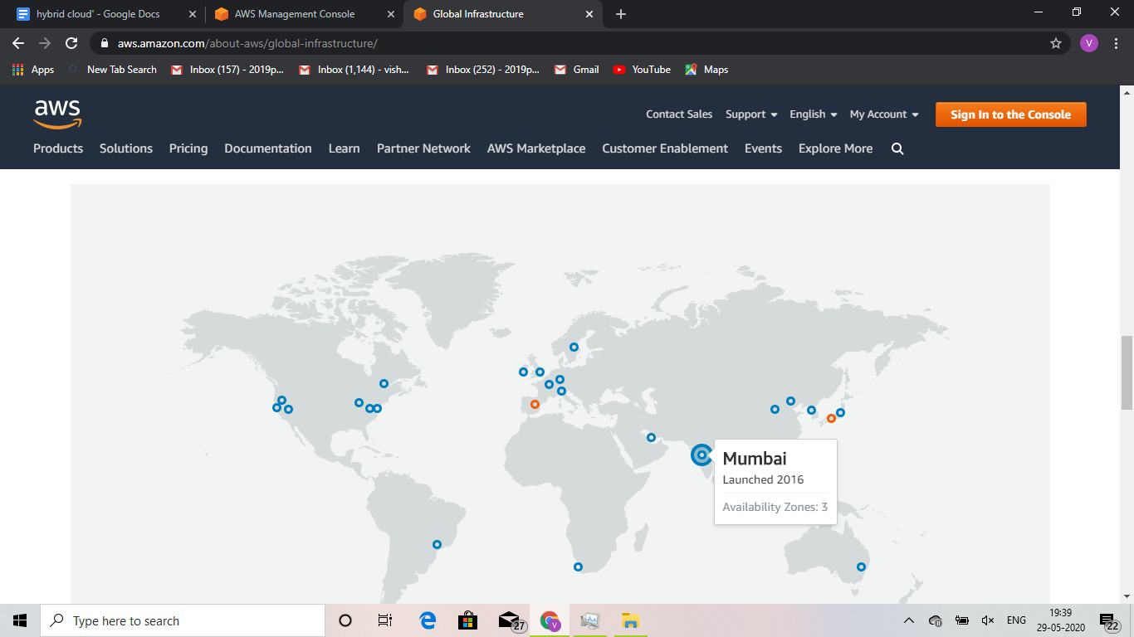

AZ:availabiity zone

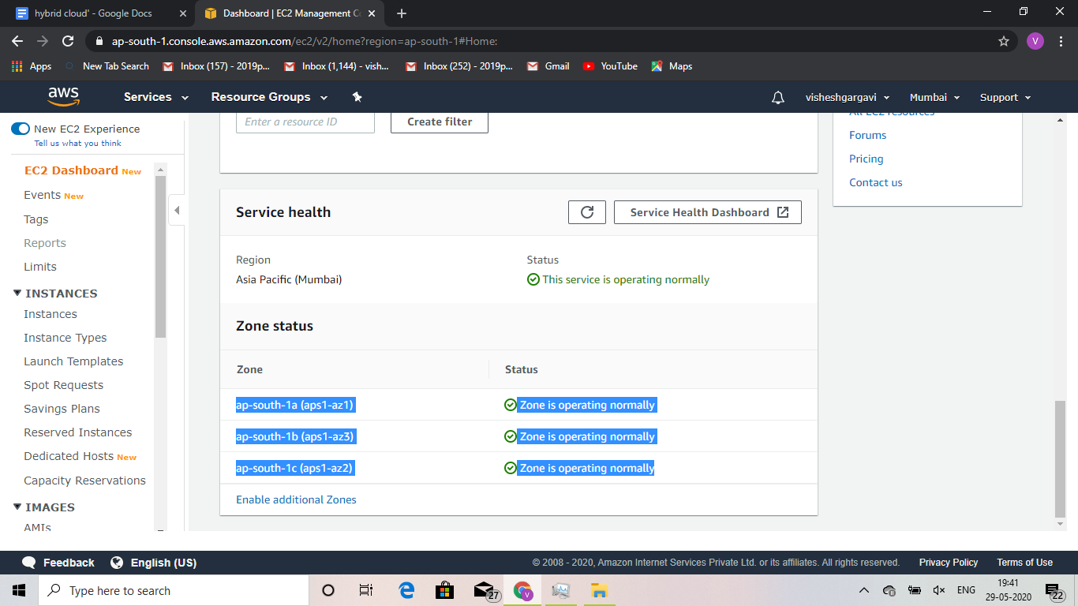

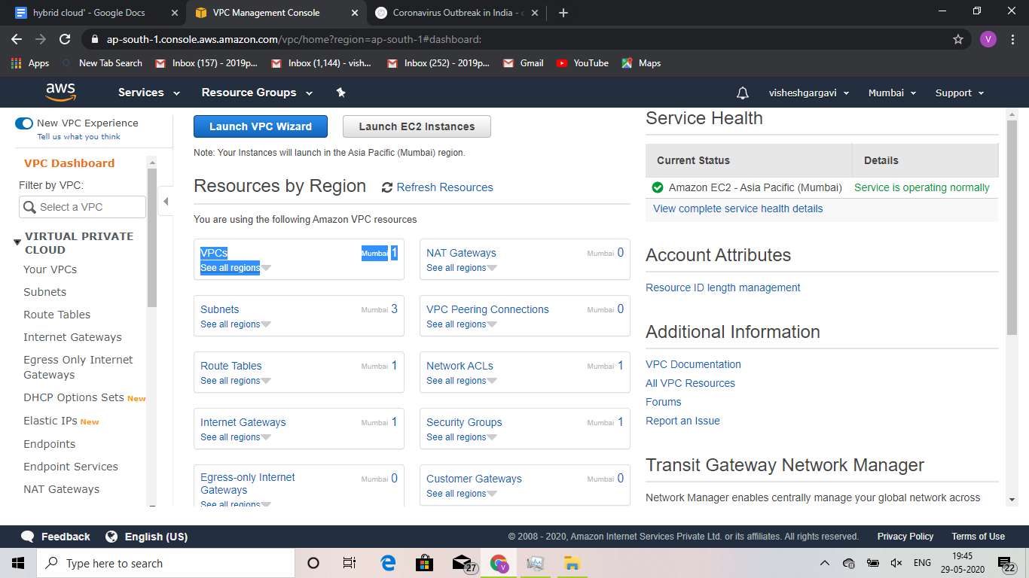

os=instance=vm[on cloud]

ENI: elastic network interface

AMI: amazon machine image

Authentication: password support on cloud(ssh keygen)

Step1:to create a key

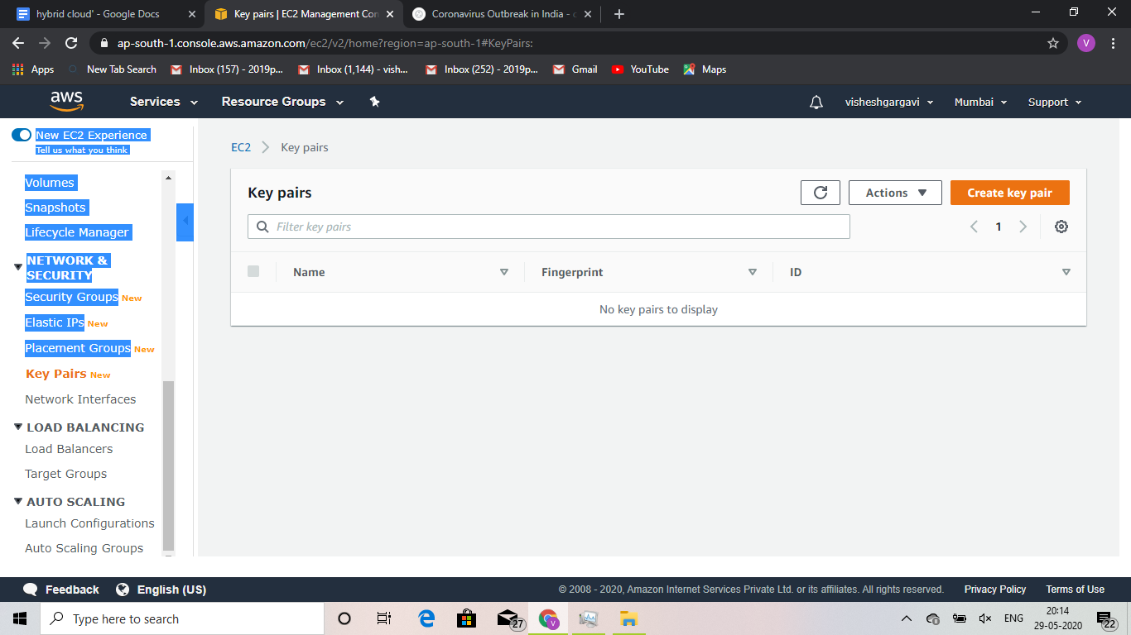

Tap create key pair

#file is imp as it content password

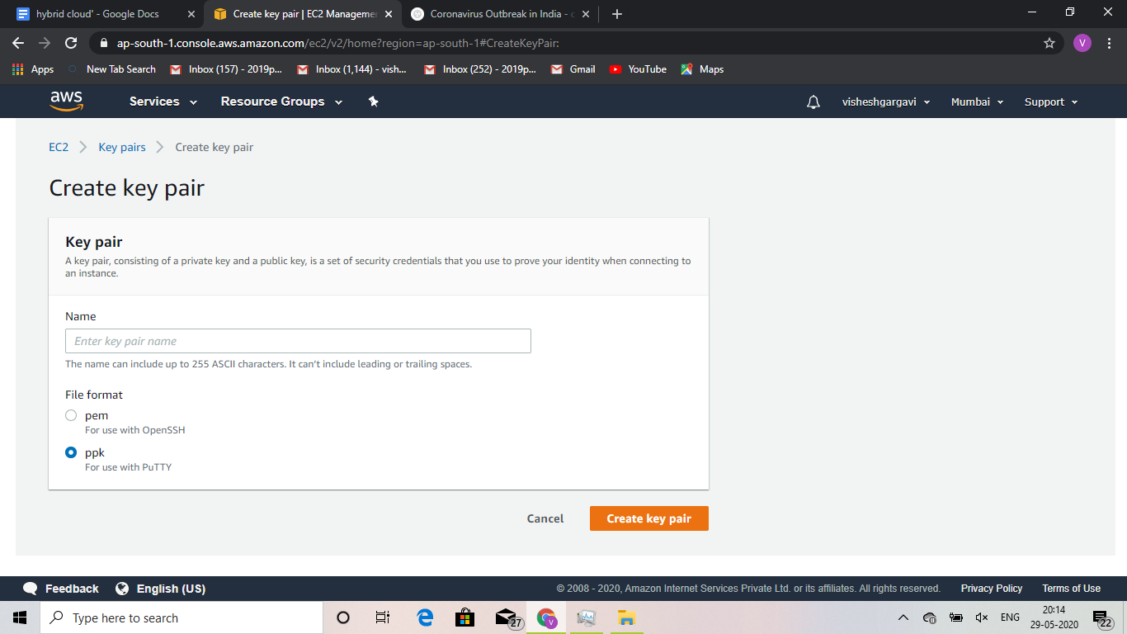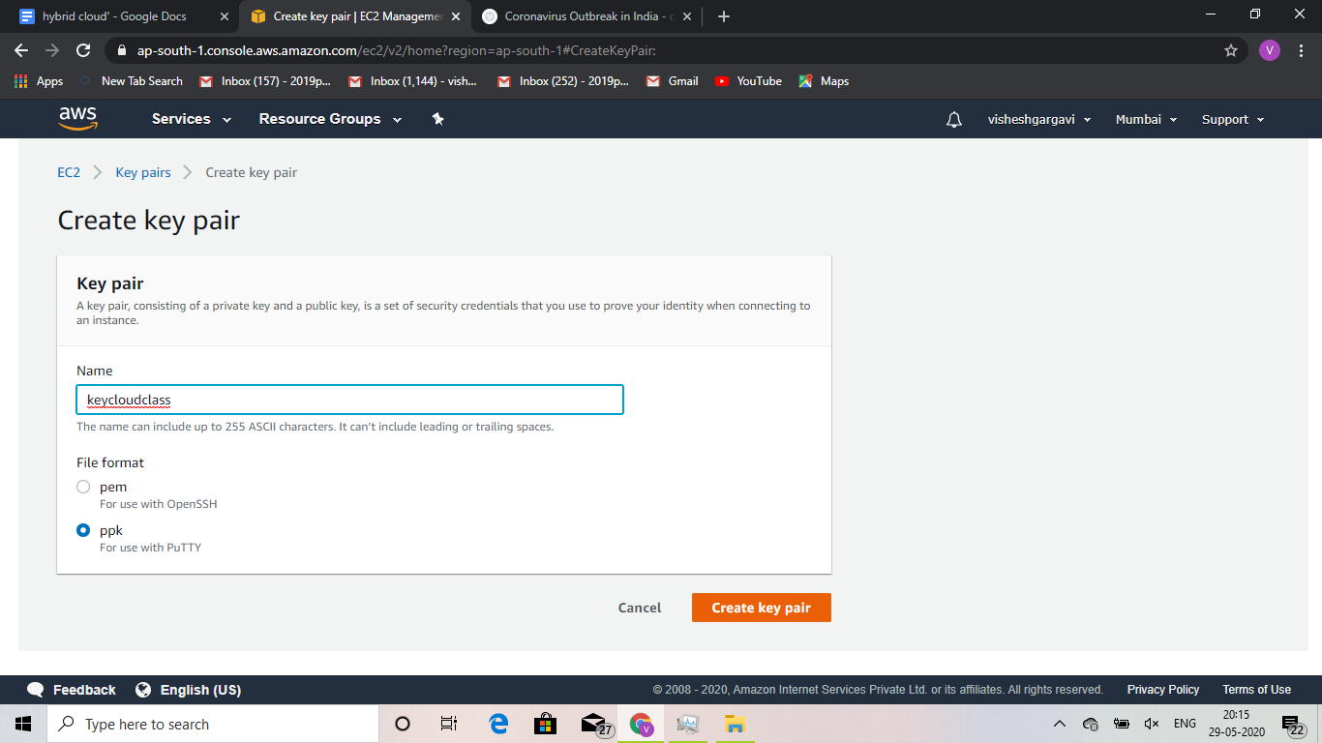

Step2: lauch the os with ram and cpu

